Piamonte,Jethro Angelo G.

Part 1-Setting,Shared Variables
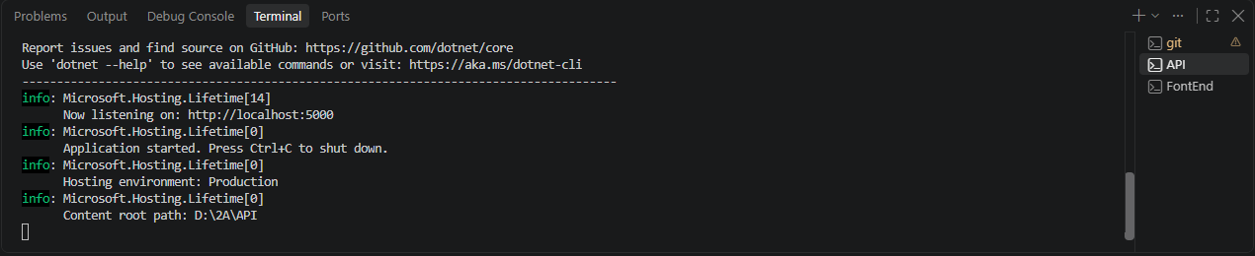
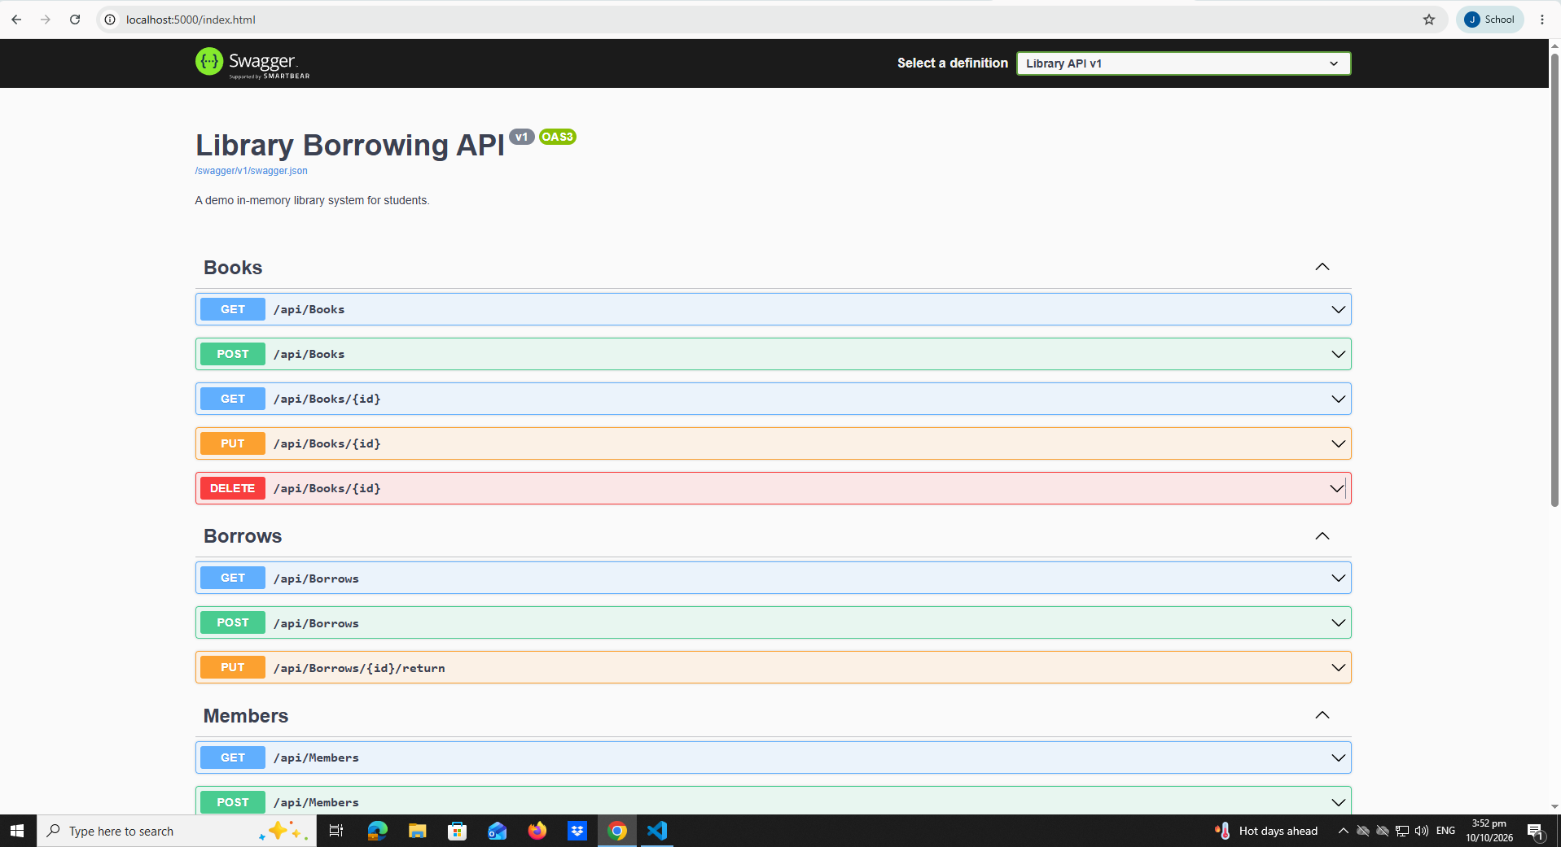

Part 2- Toast Message
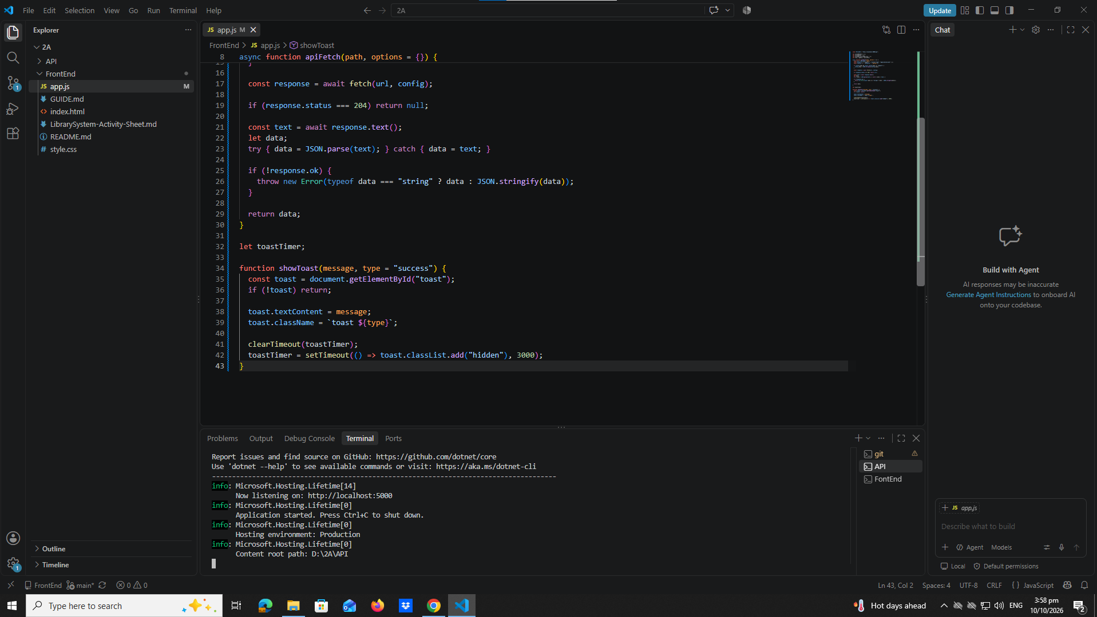
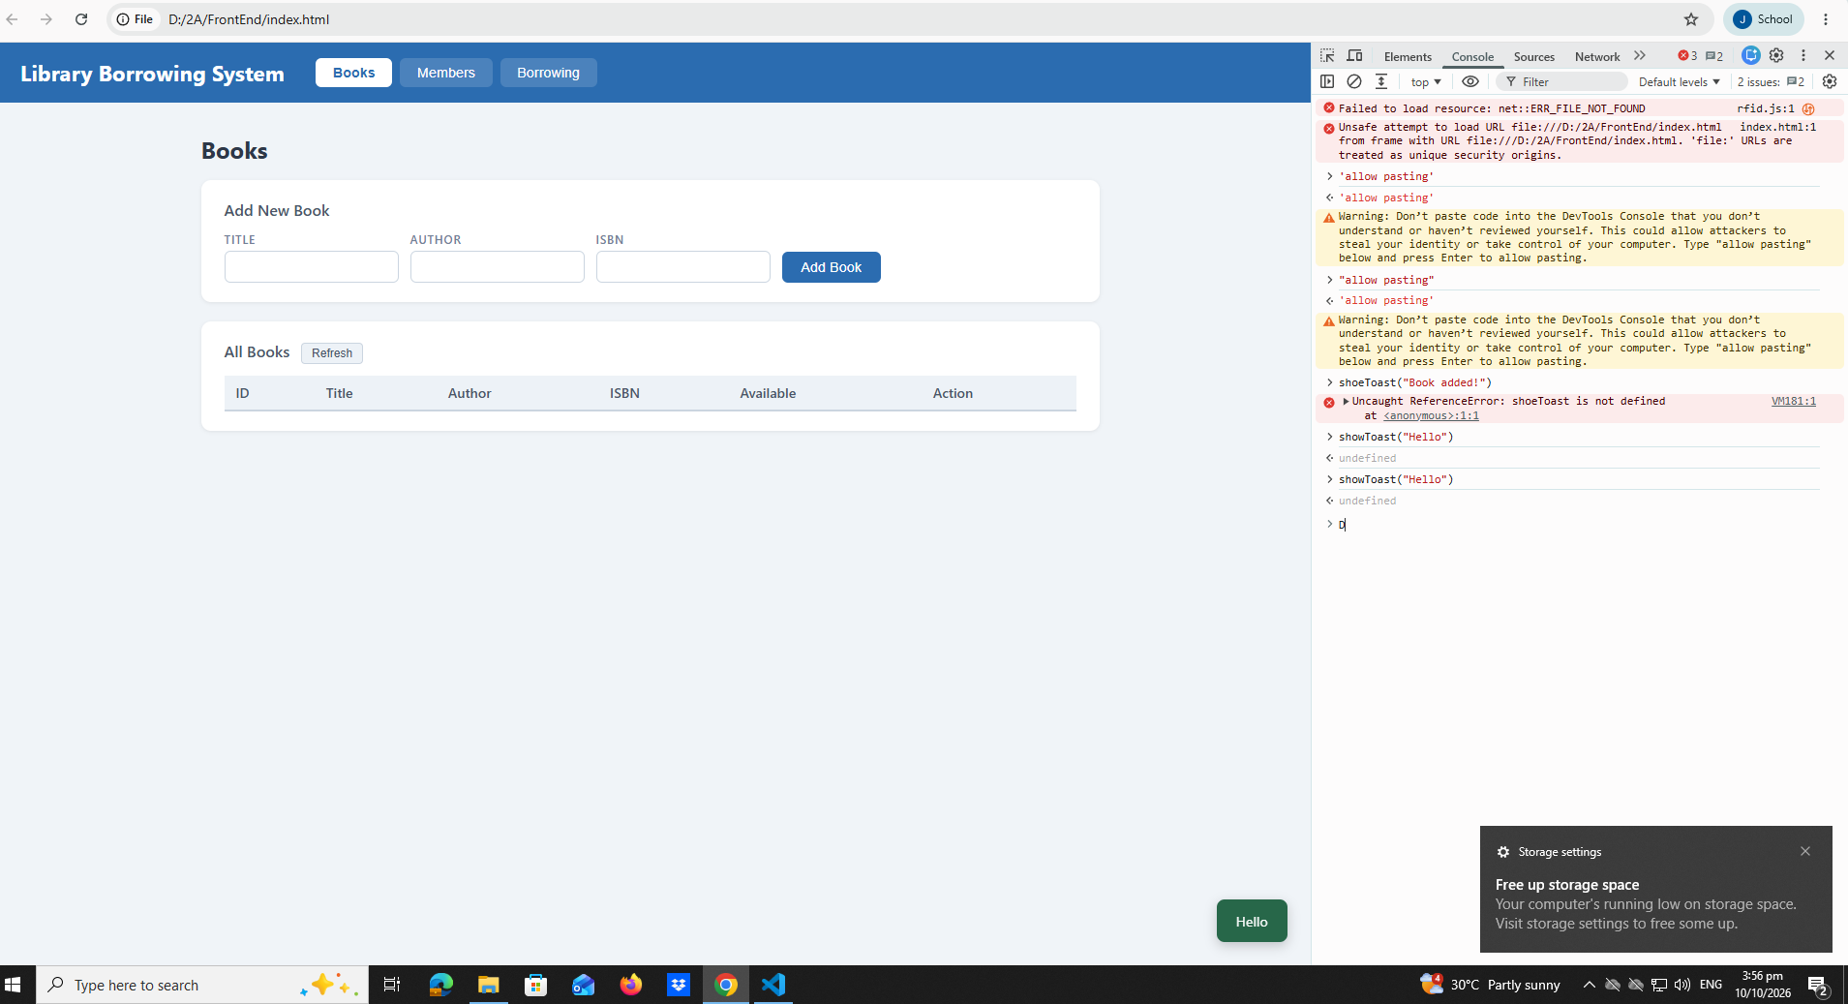

Part 3-Cache and find member by RFID
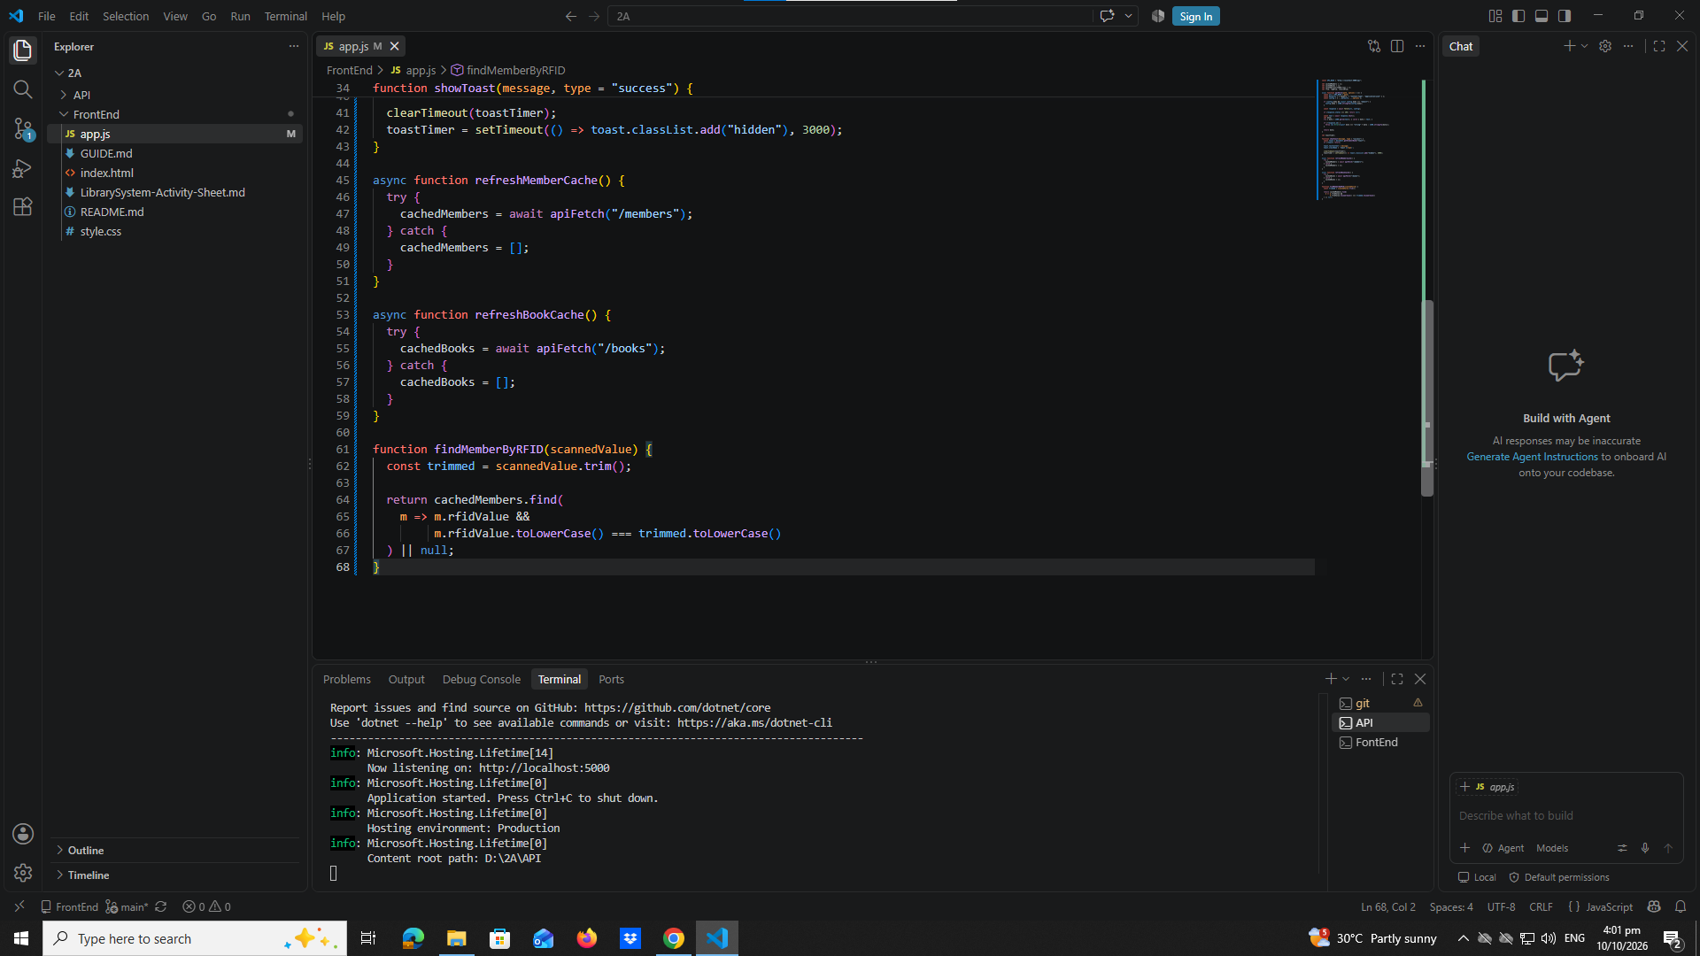
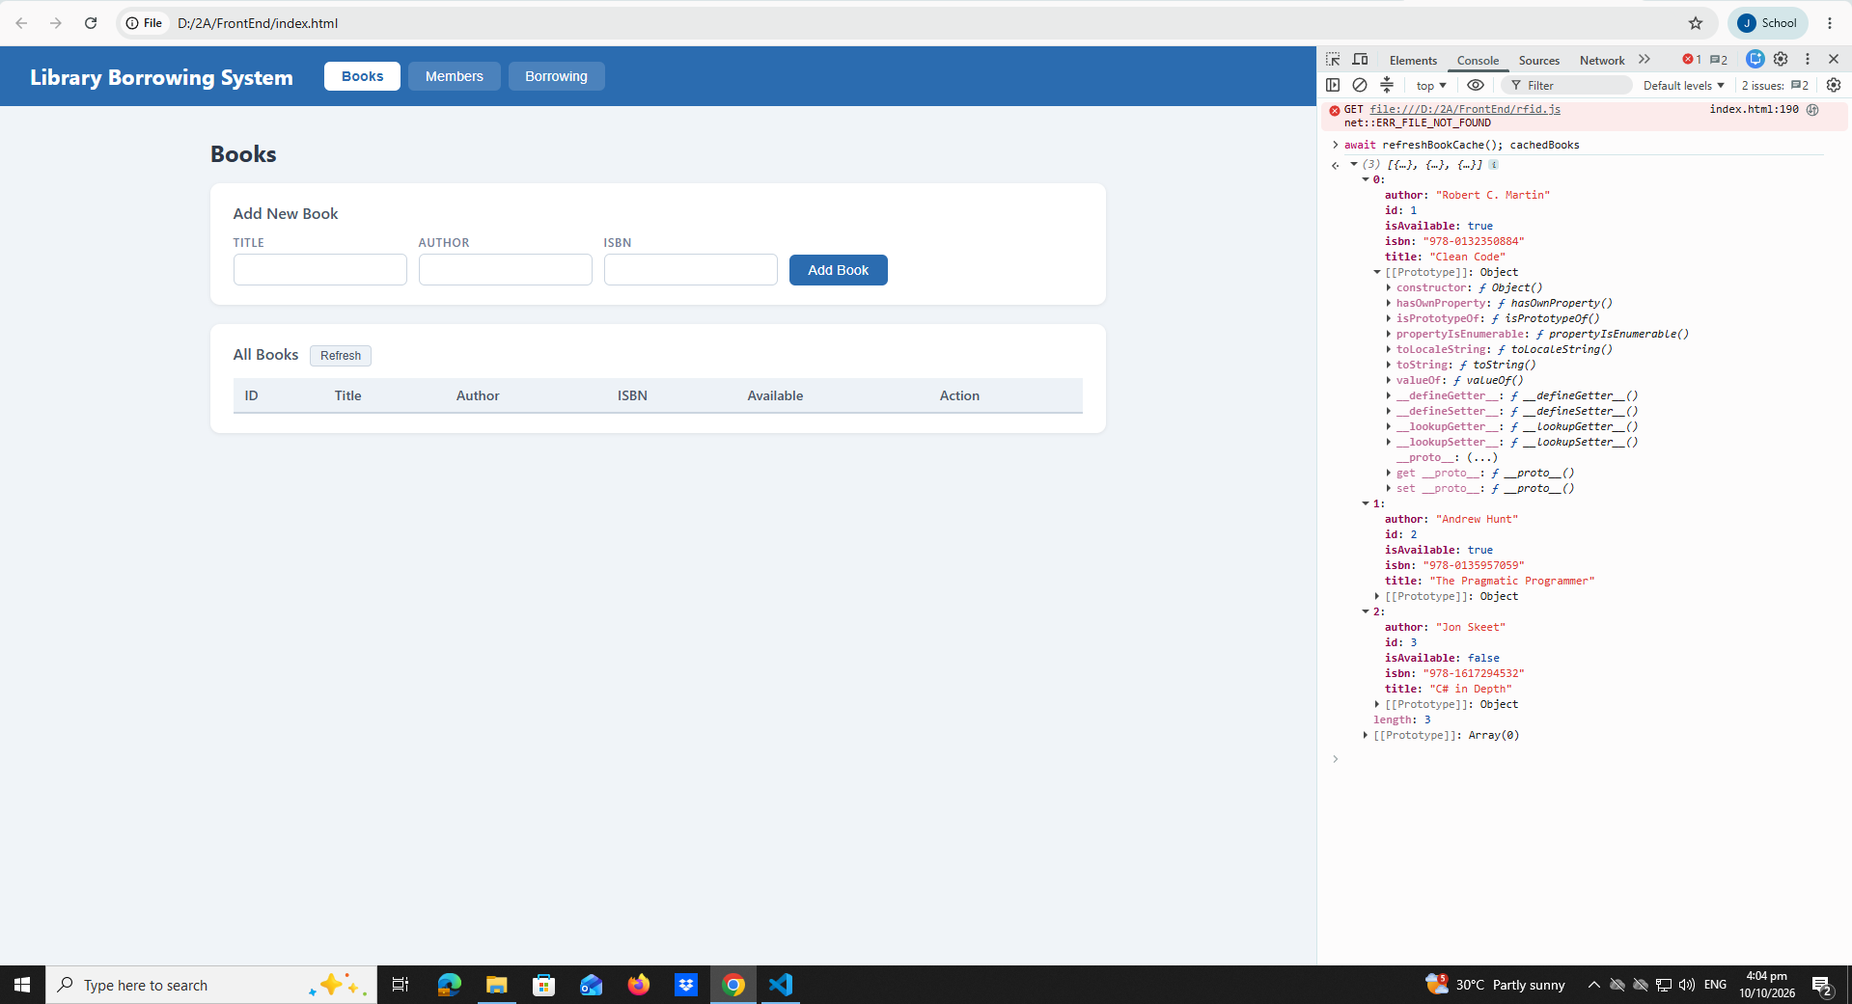

Part 4-Tabs and Refresh buttons
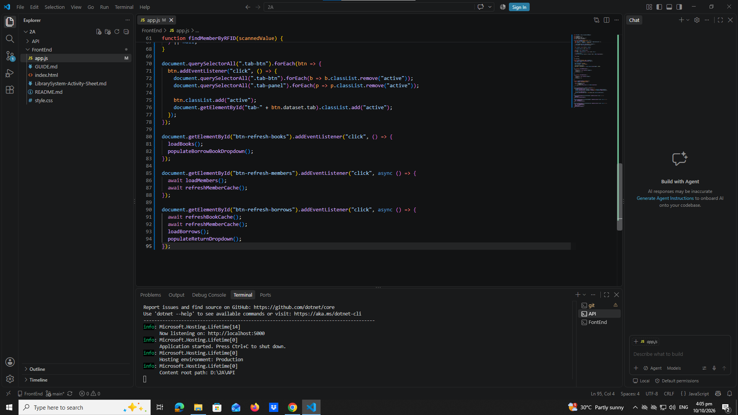
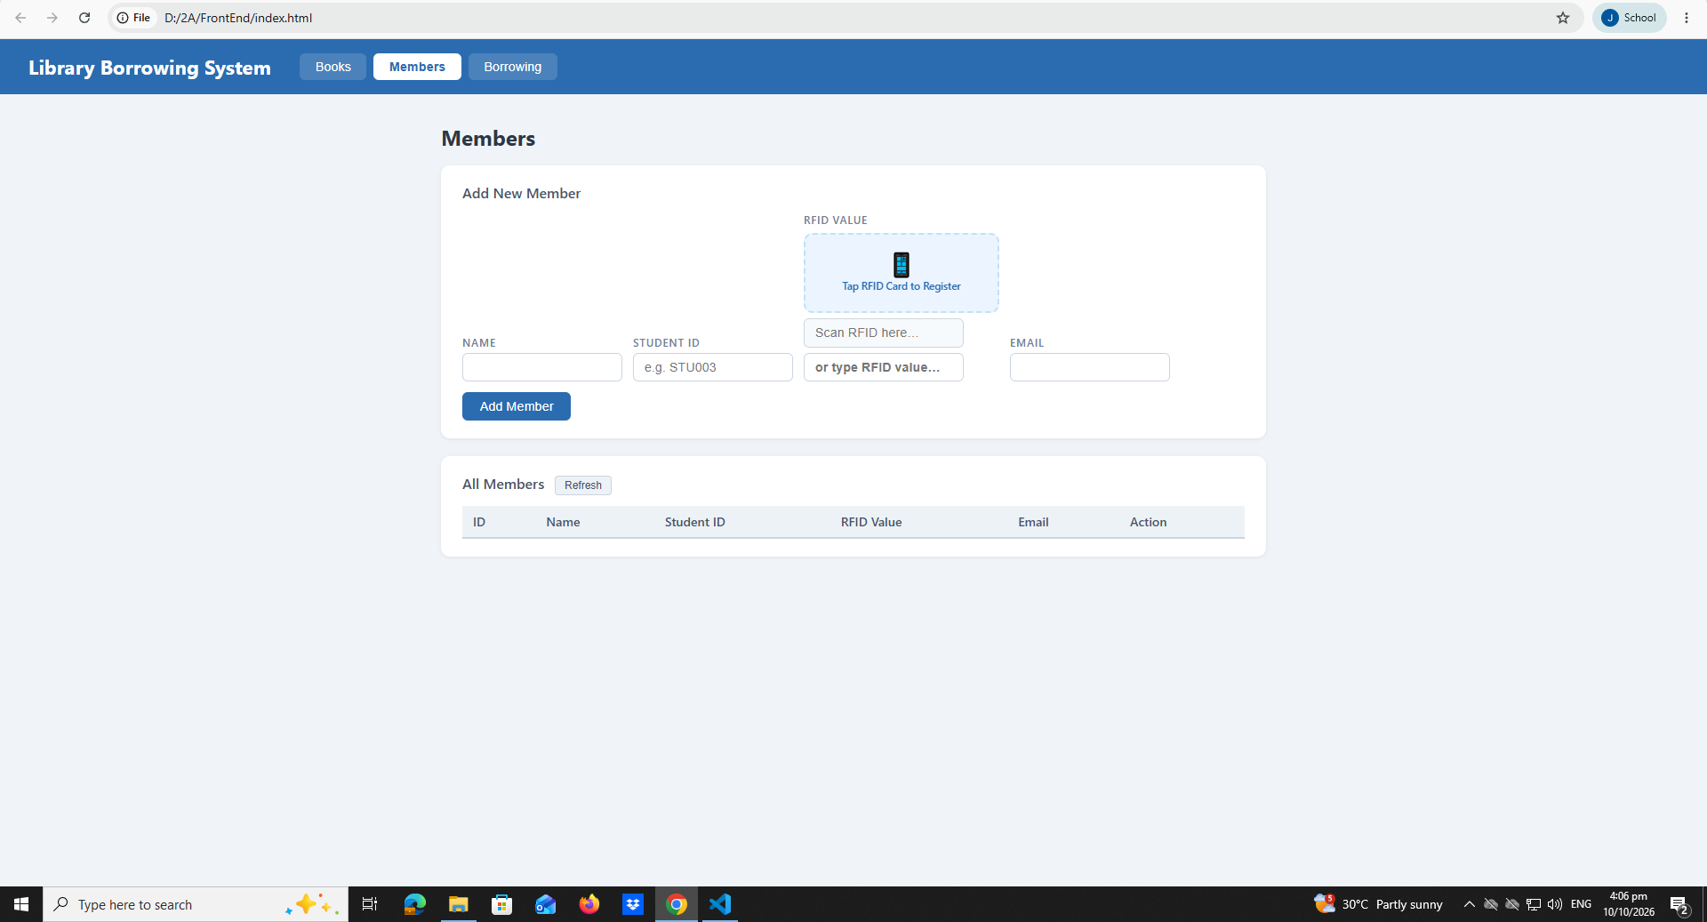

Part 5-Load Books
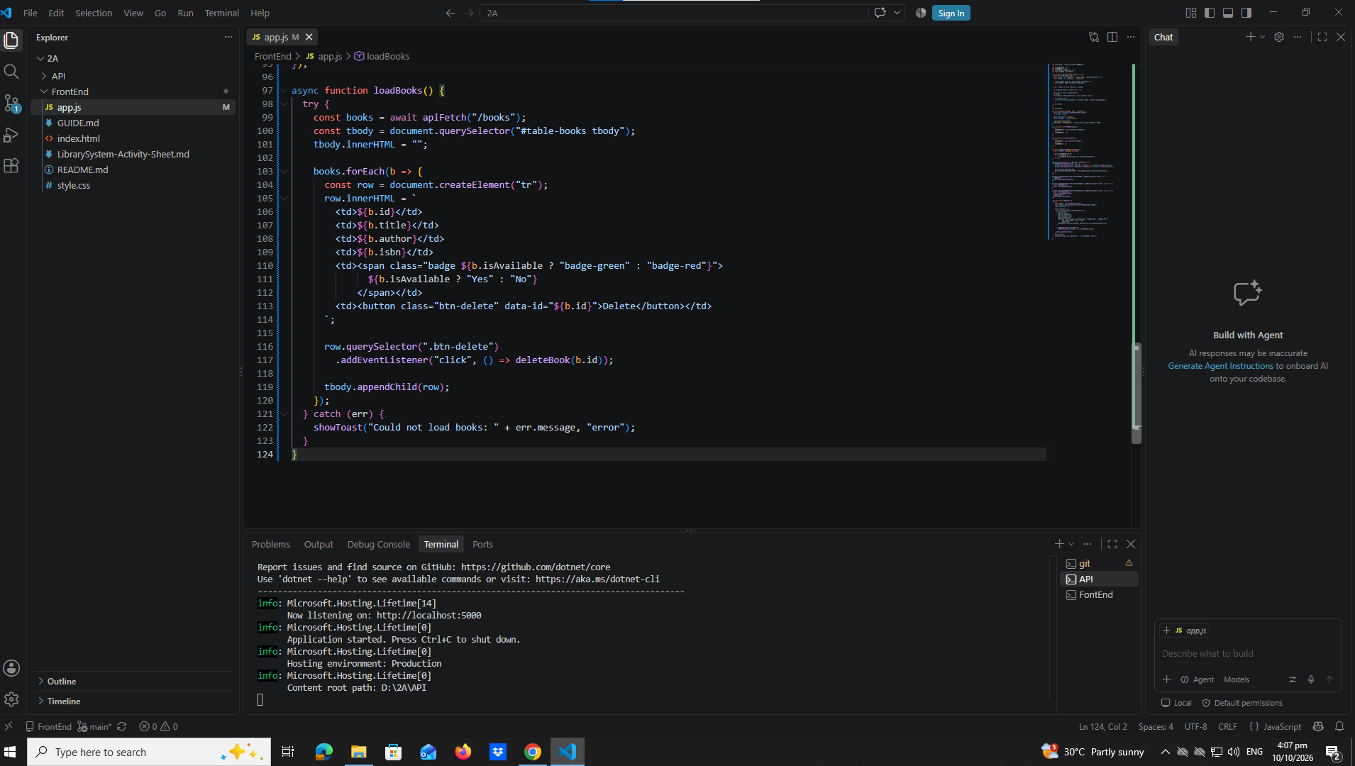

Part 6-Delete Book
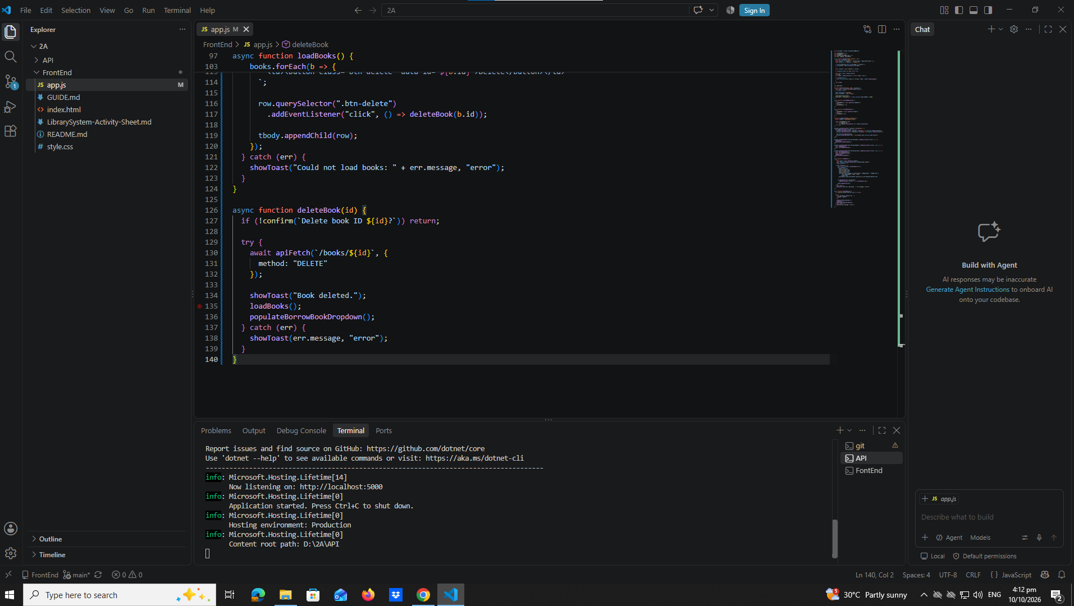

Part 7-Add Book
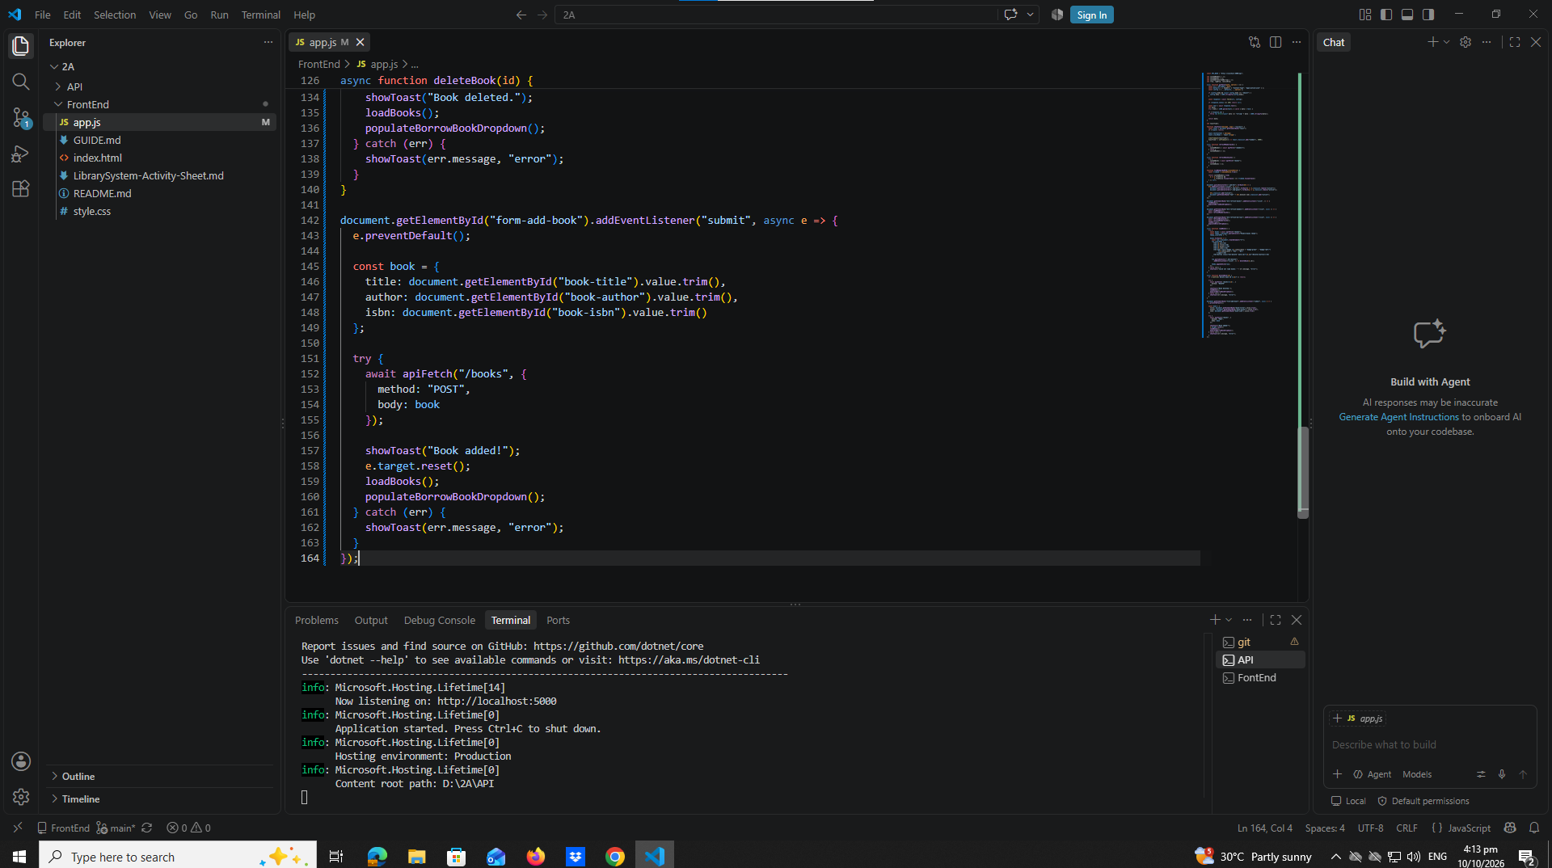
Part 8-Load Members Into Table
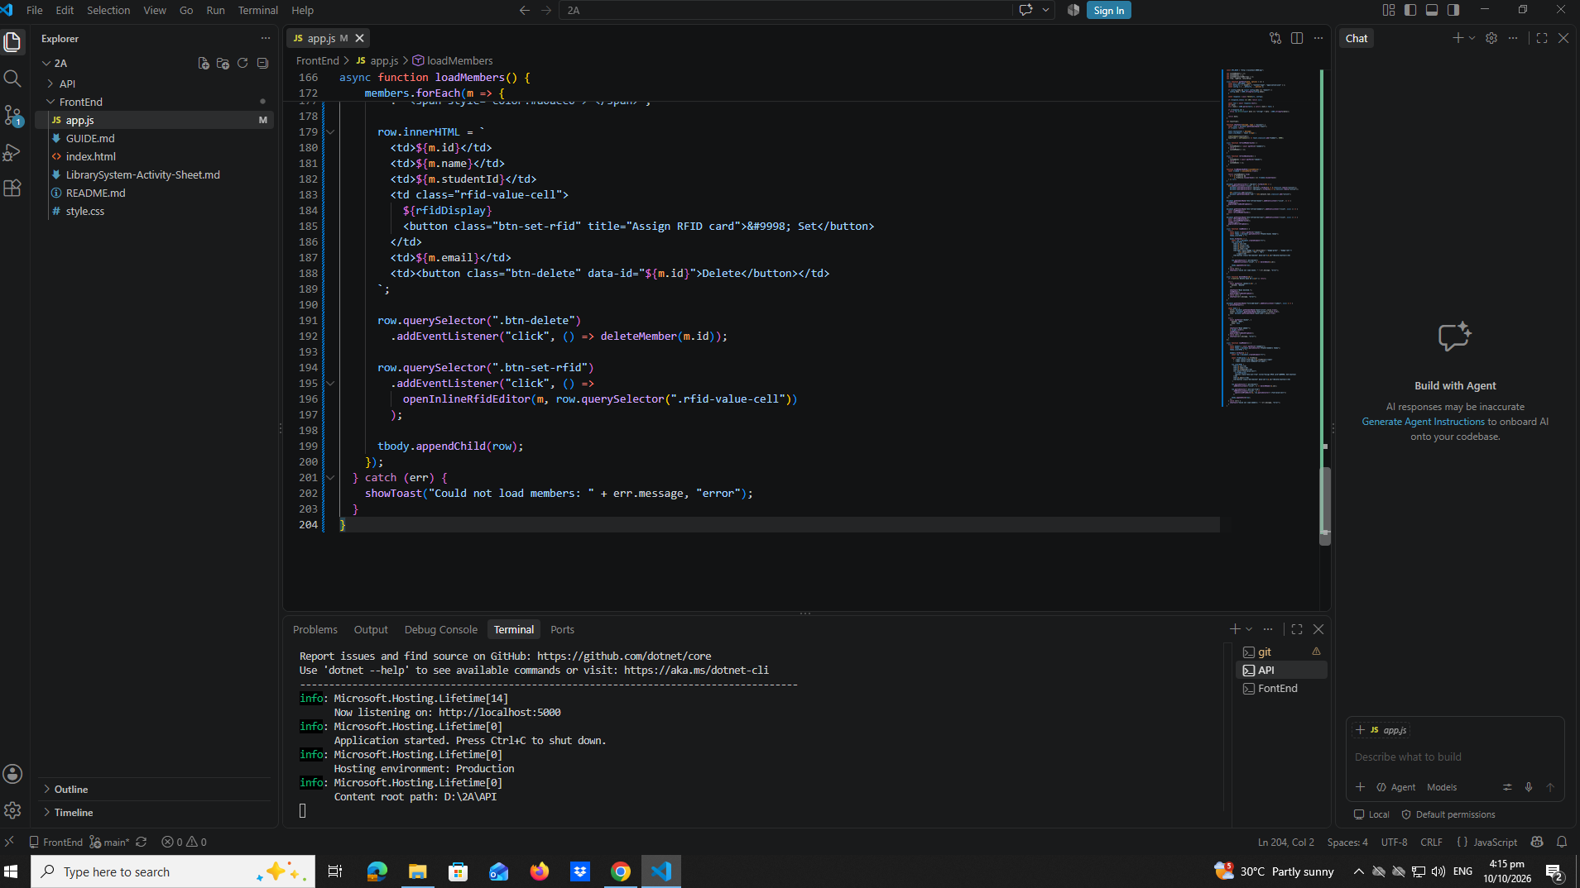

Part 9-Delete Member
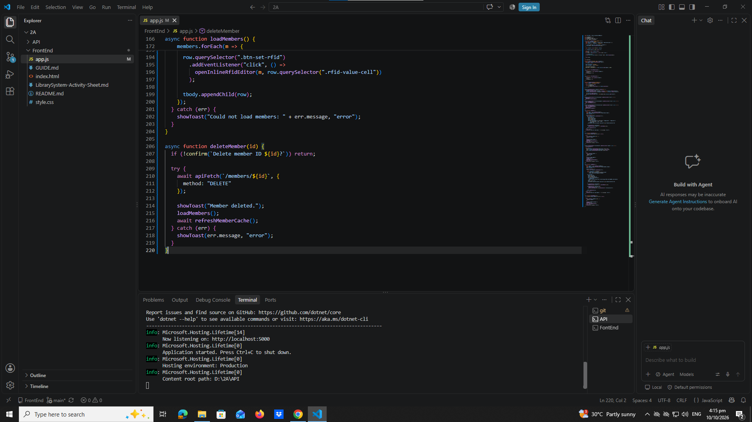
Part 10-Add Member With RFID Value
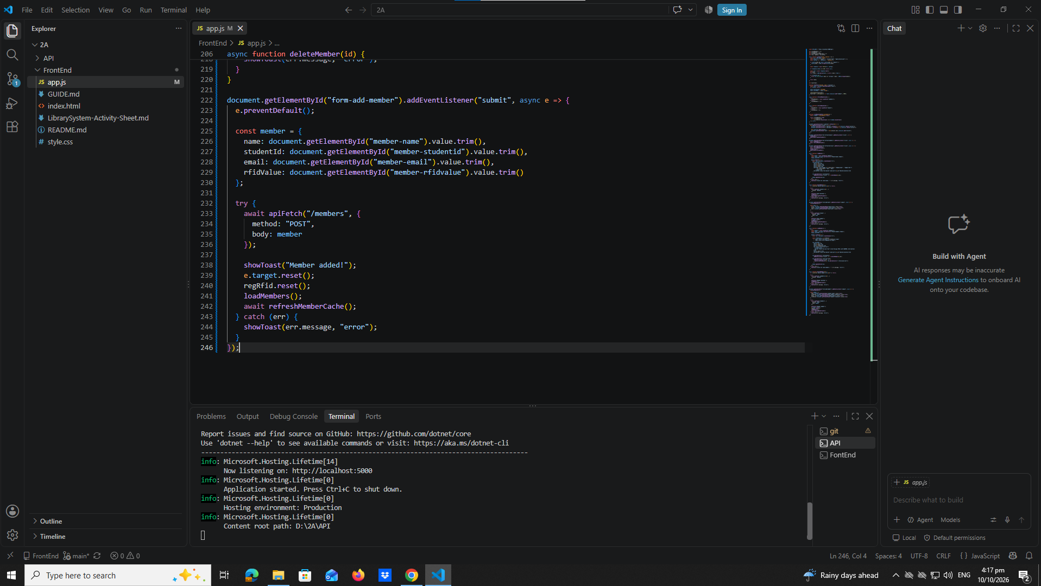

Part 11-Inline RFID Editor And Update Member RFID
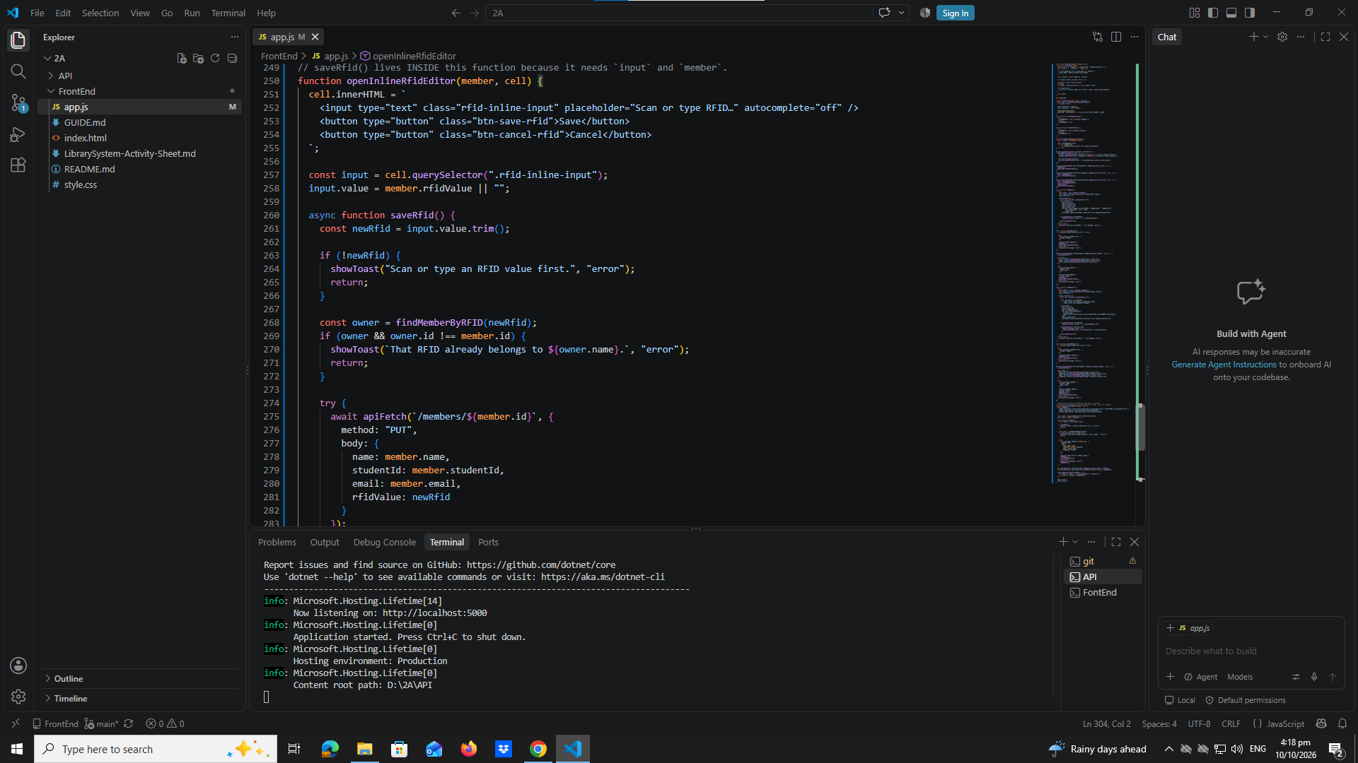
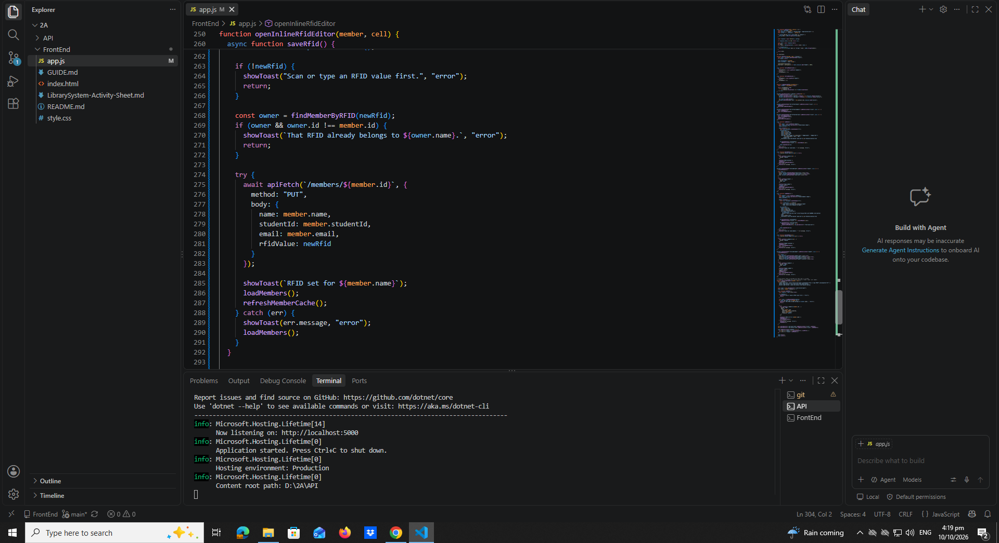

Part 12-RFID Widgets(Borrow,Register,Return)
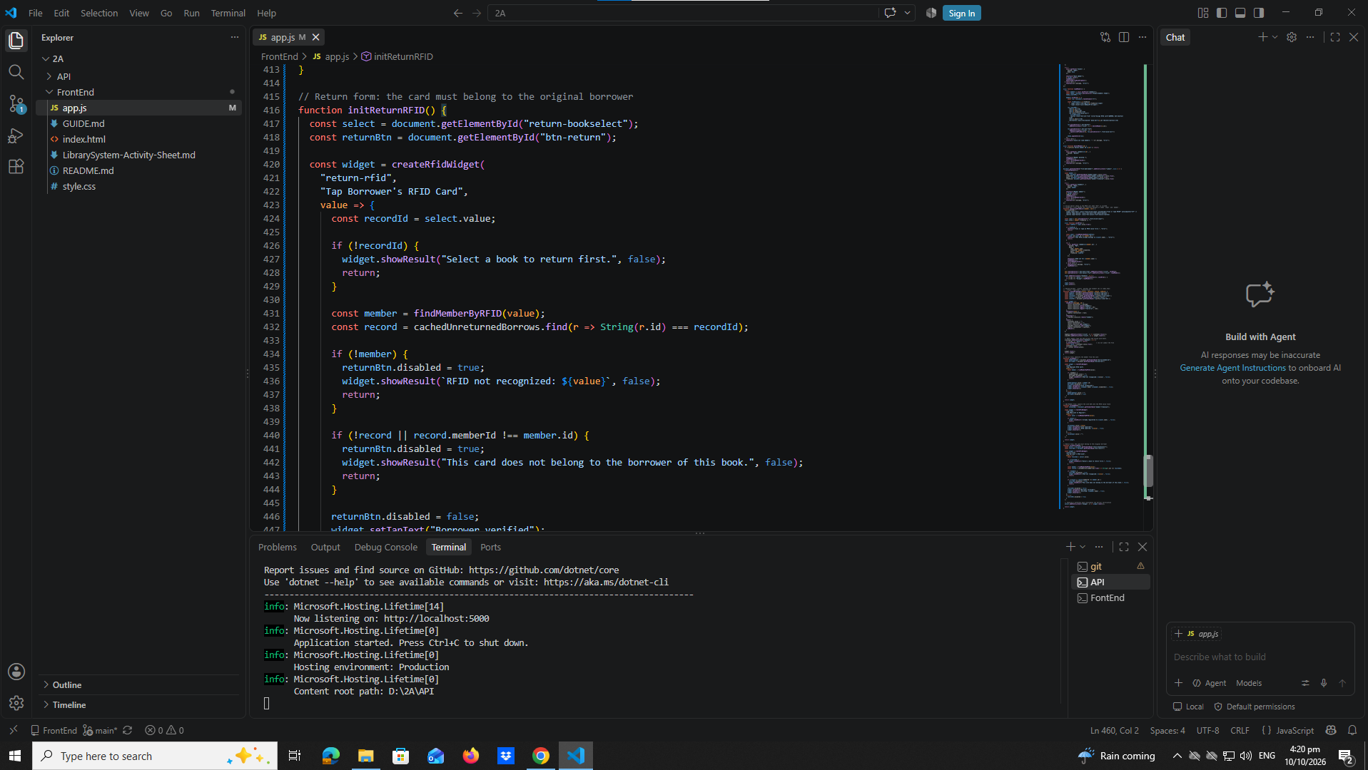
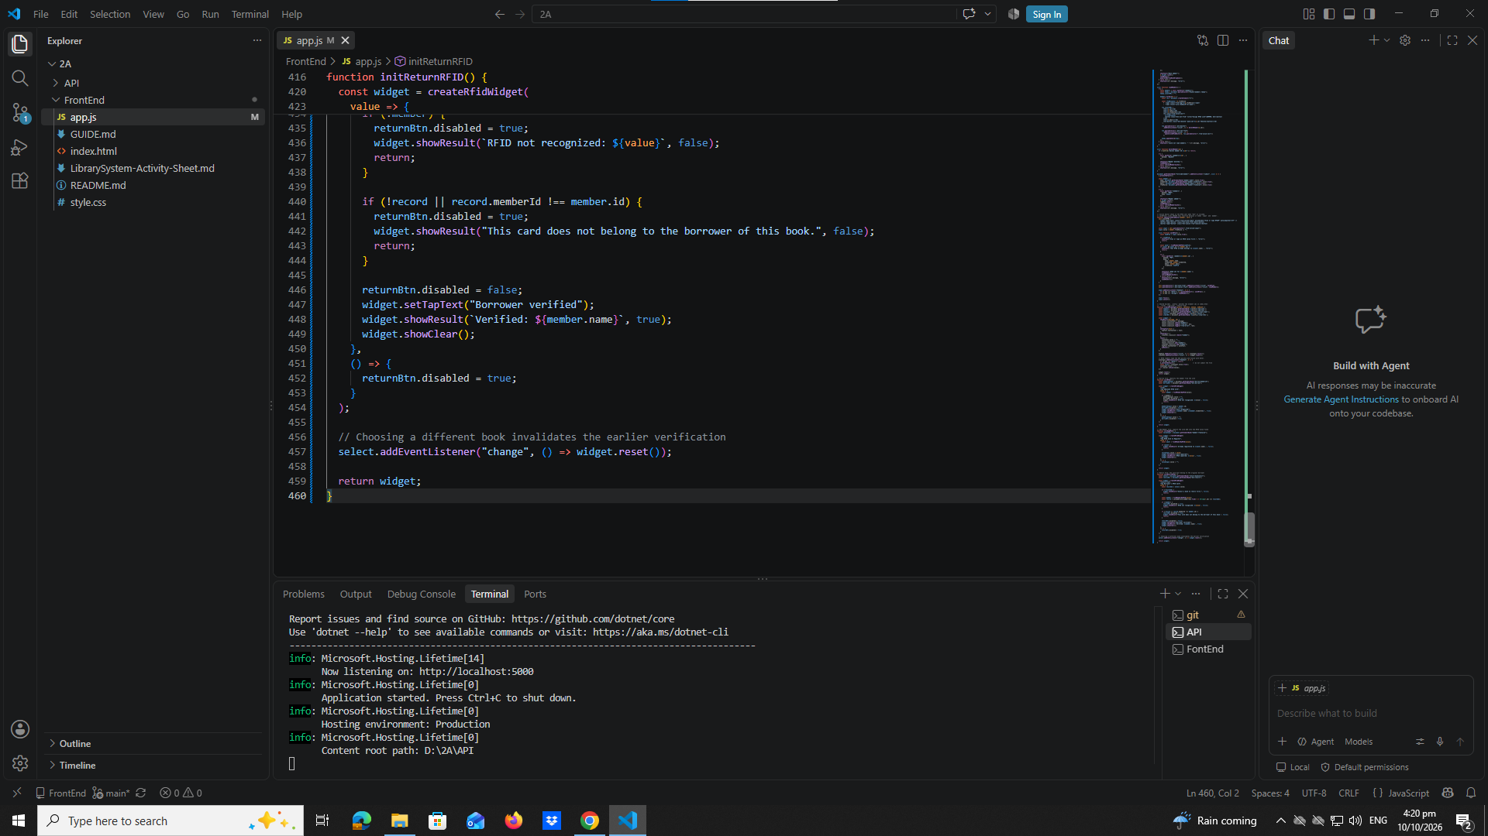

Part 13-Populate Borrow Book DropDown
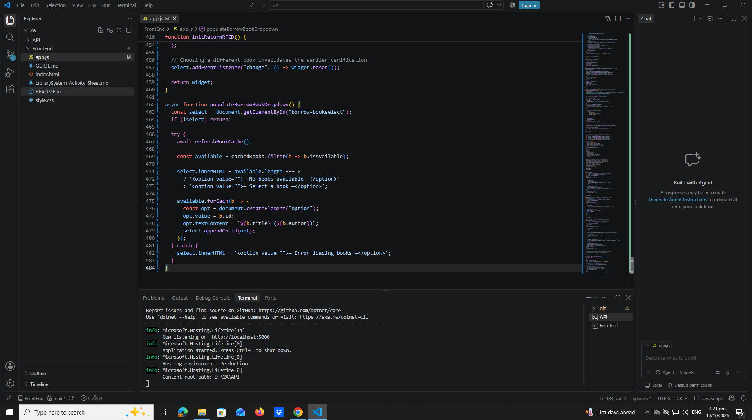

Part 14-Populate return Book DropDown
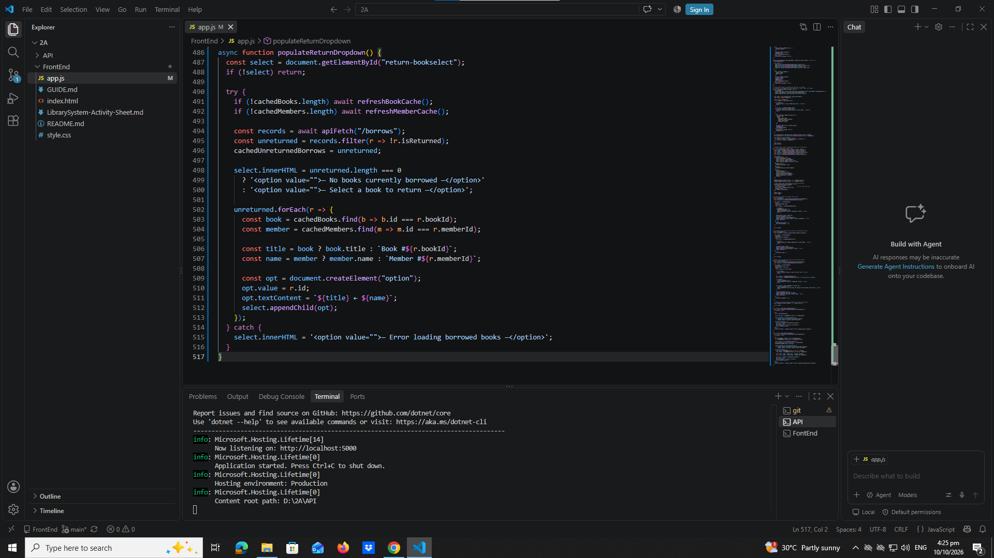

Part 15-Borrow a Book
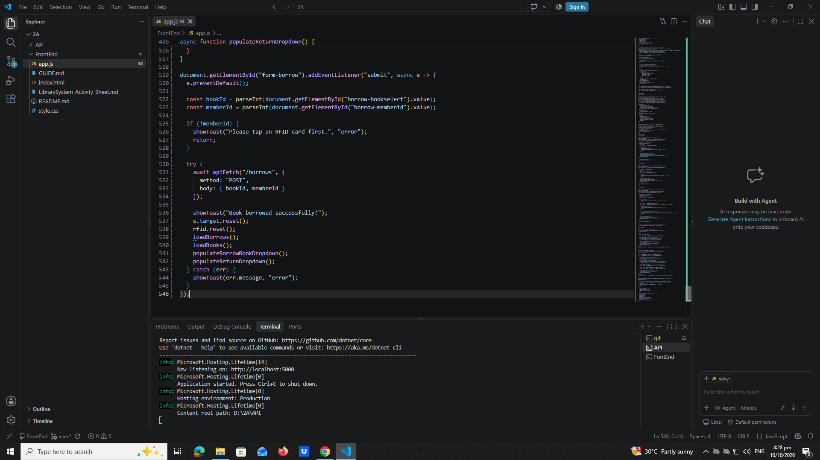
Part 16-Return a Book
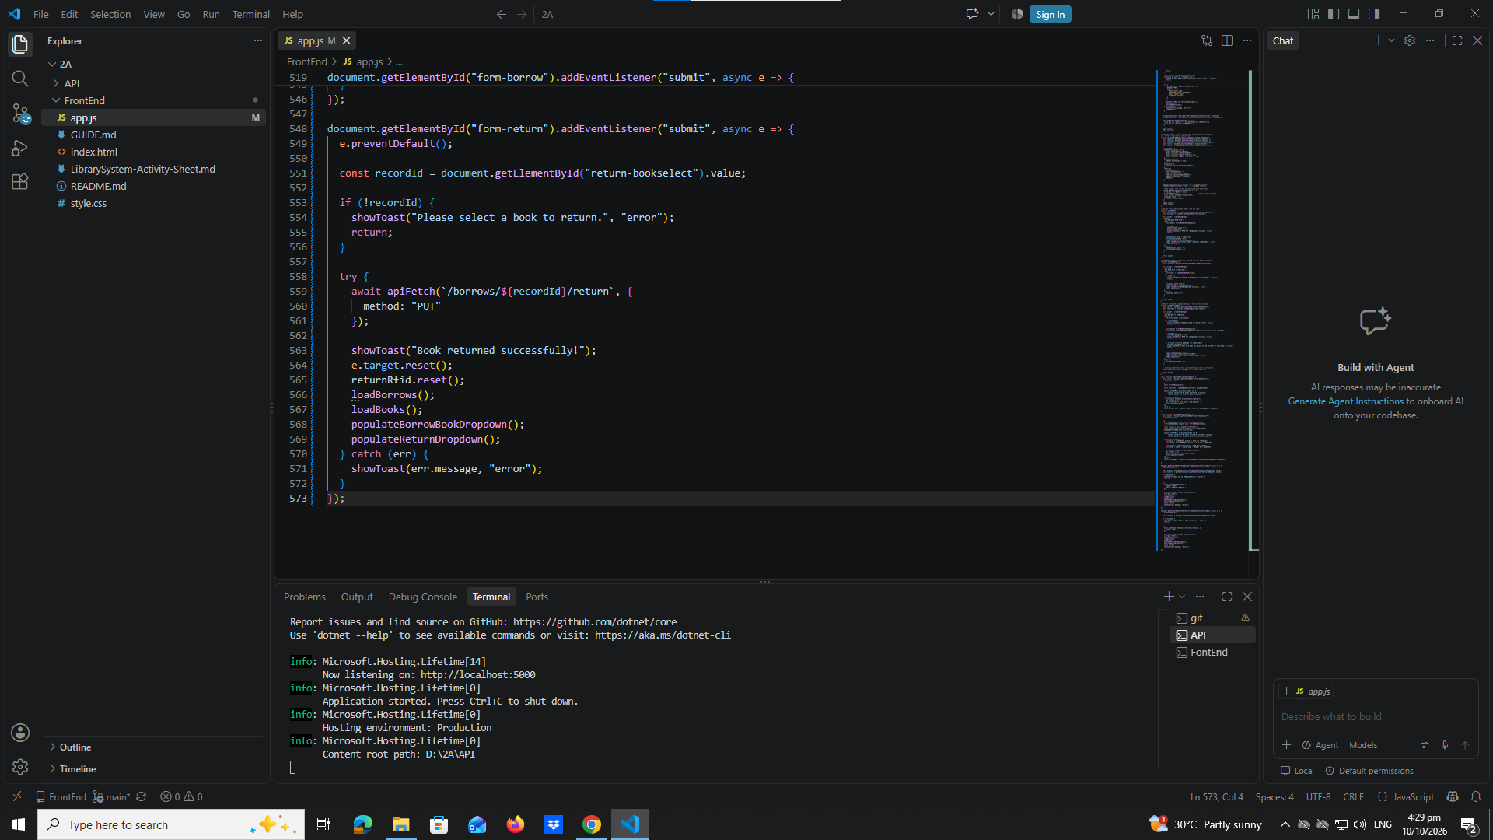

Part 17-Load Borrow History table
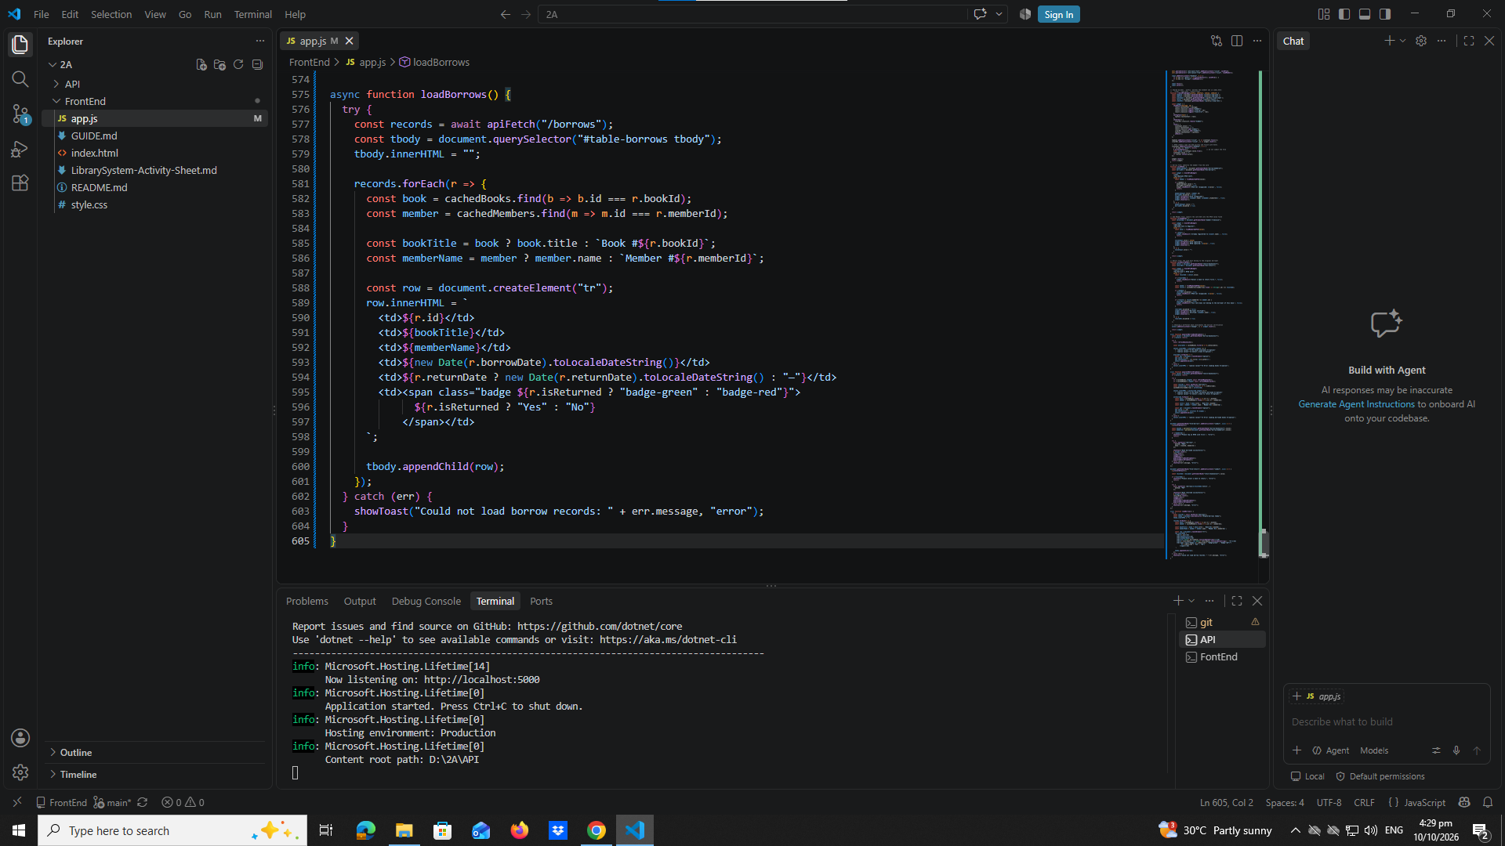

Part 18-Initial Page Load
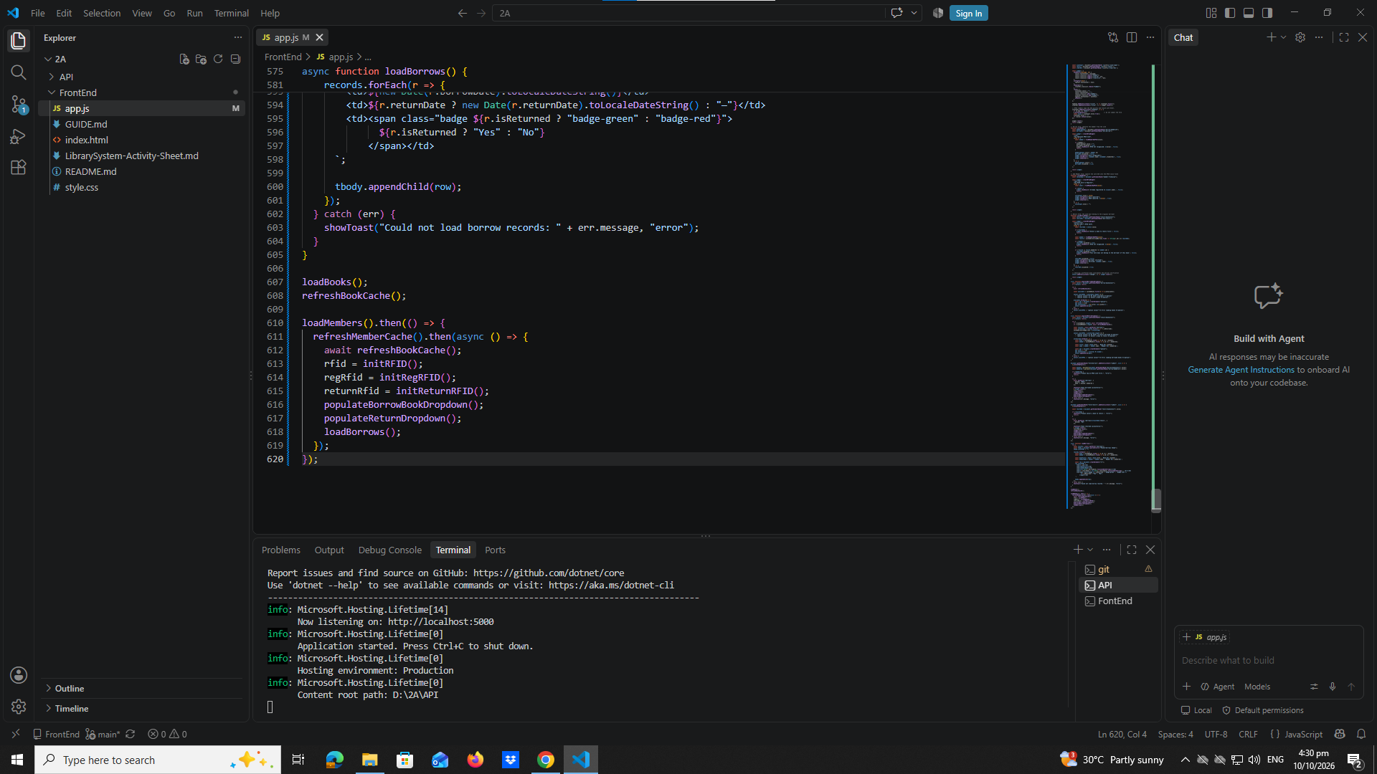

Testing Steps

1. Start the API
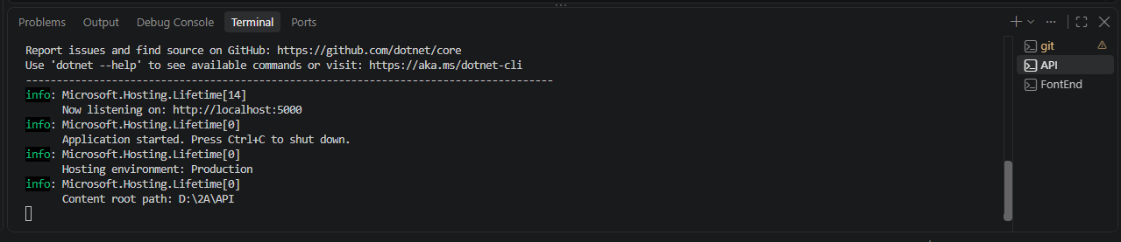

2. Open the FrontEnd
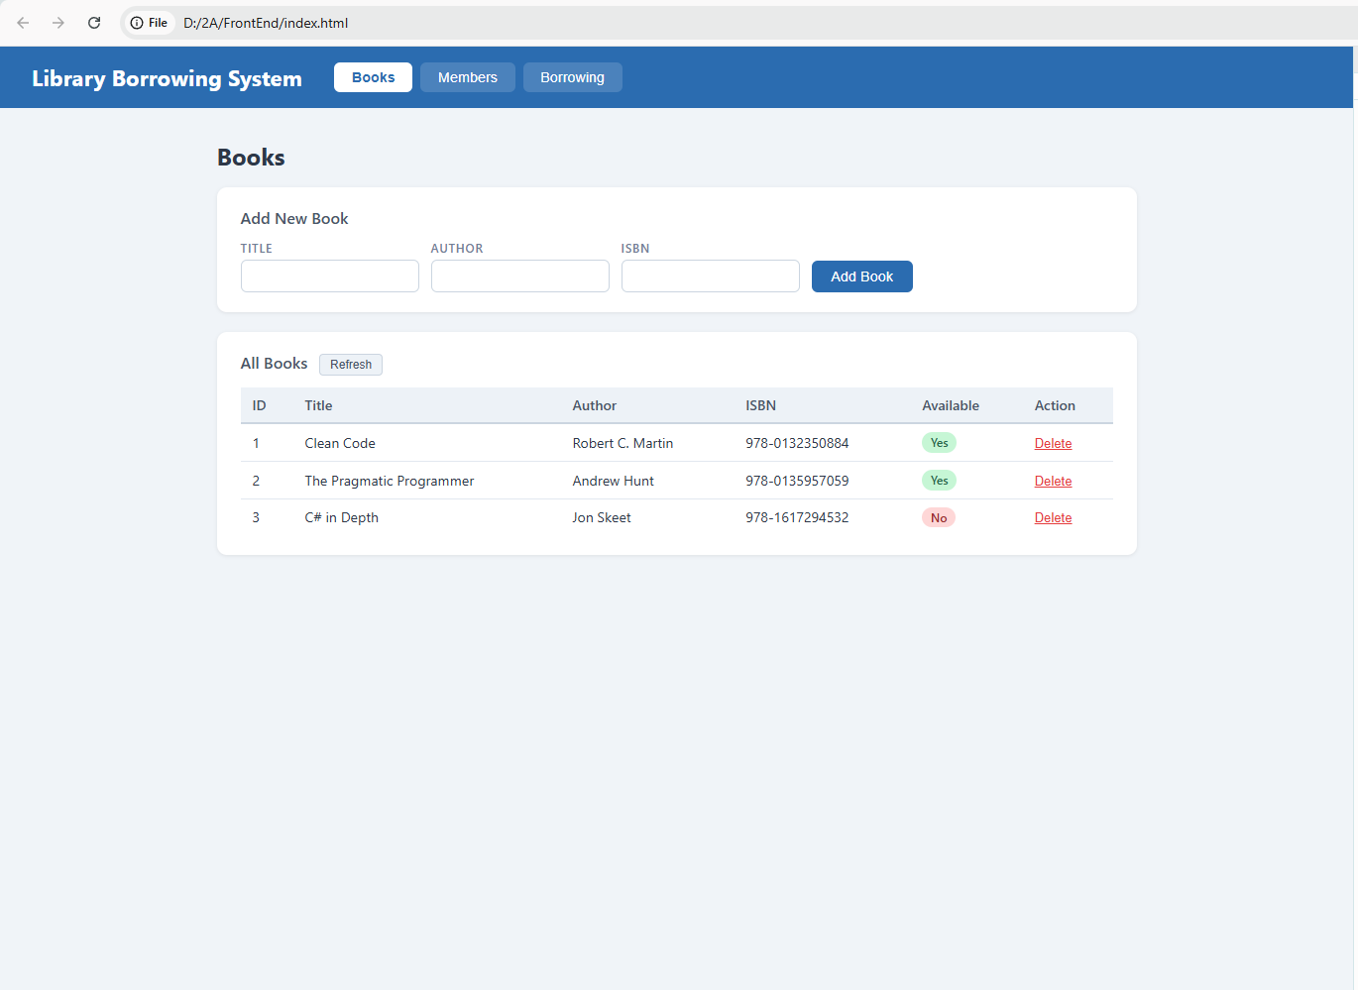

3. Test the Tabs
The tabs were already captured in early-03-tabs. No new screenshot here.

4. Test Books
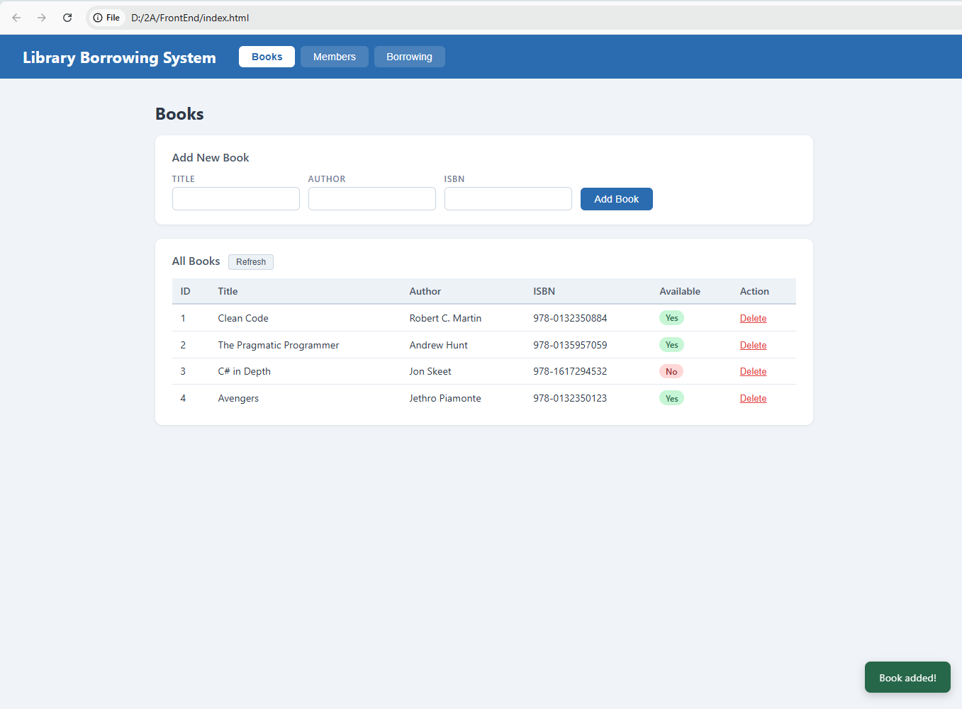

5. Test Members
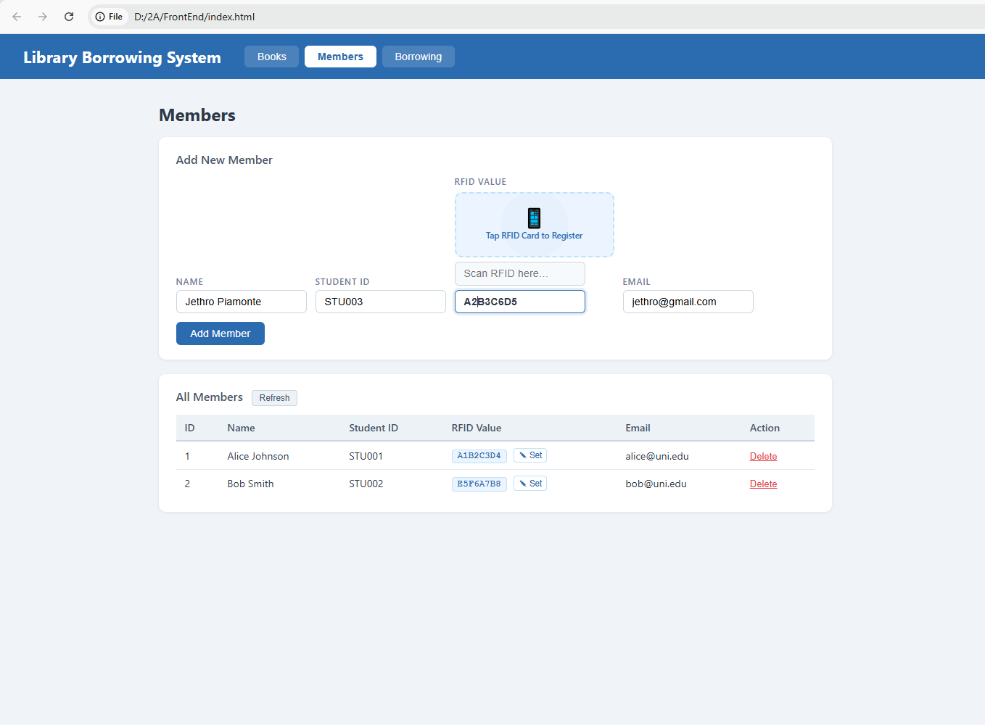

test-05-register-rfid
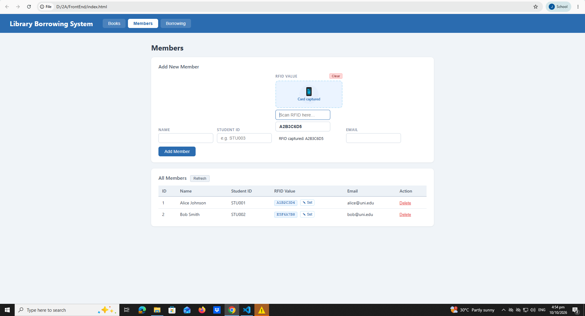
test-06-add-member
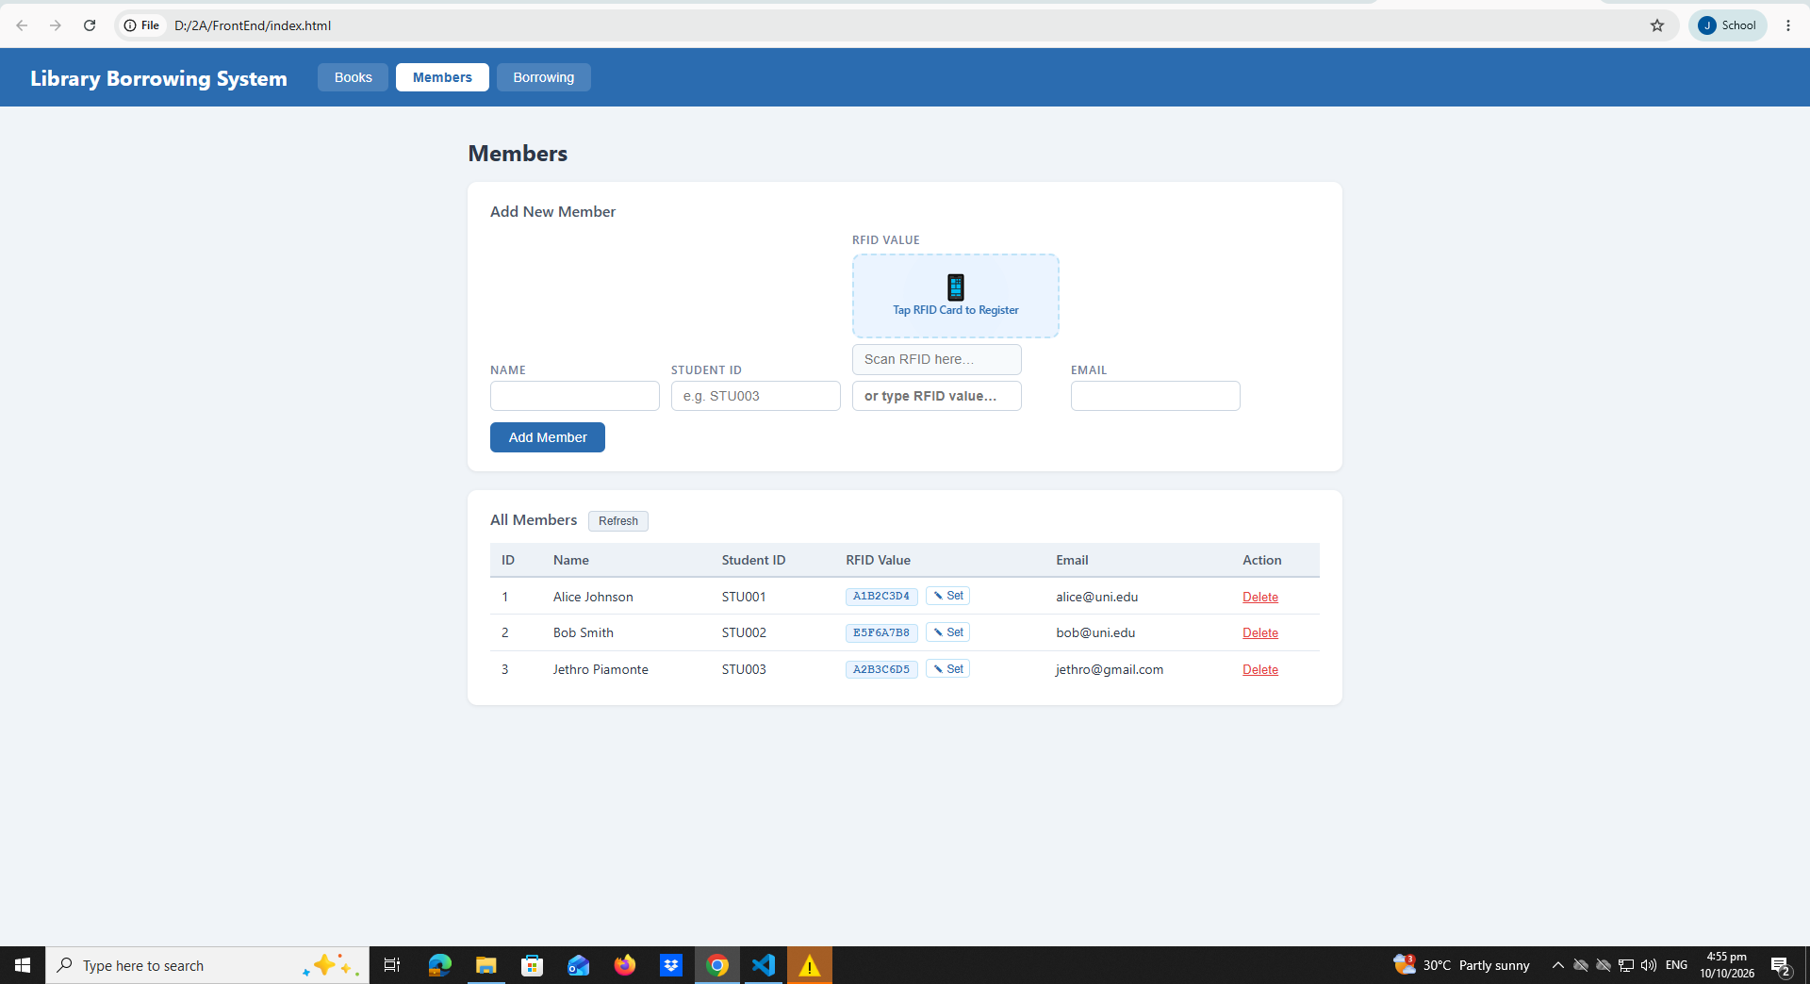

test-07-set-rfid-saved
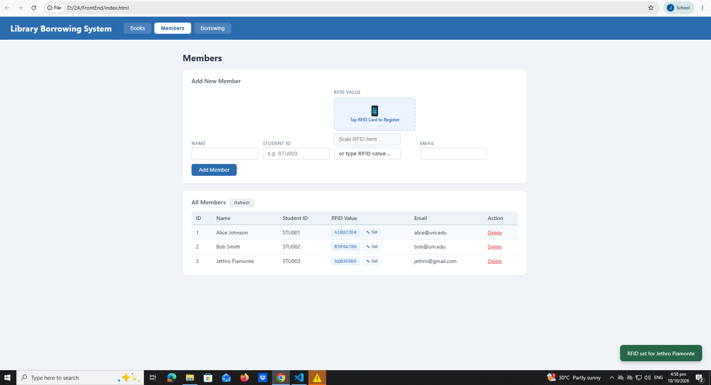

6. Test Borrowing
test-09-borrow-rfid-recognized
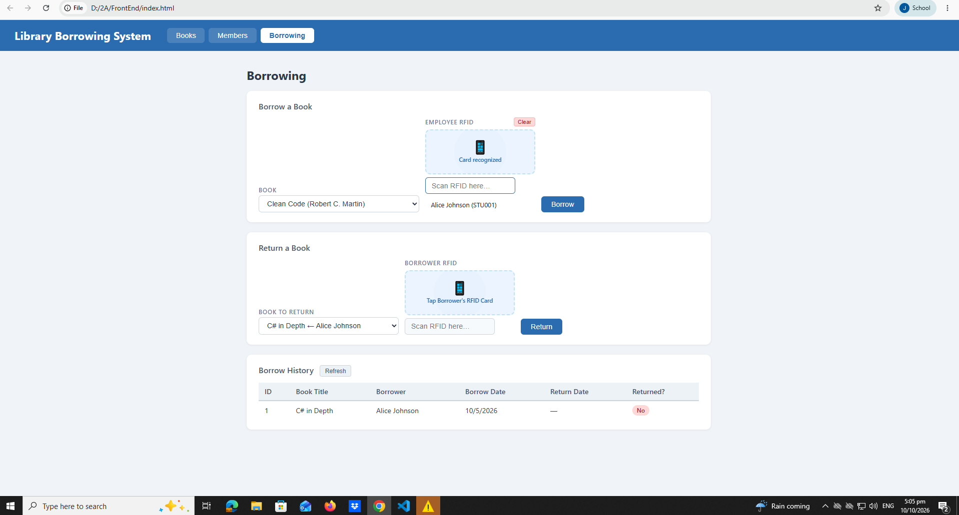

test-10-borrow-success
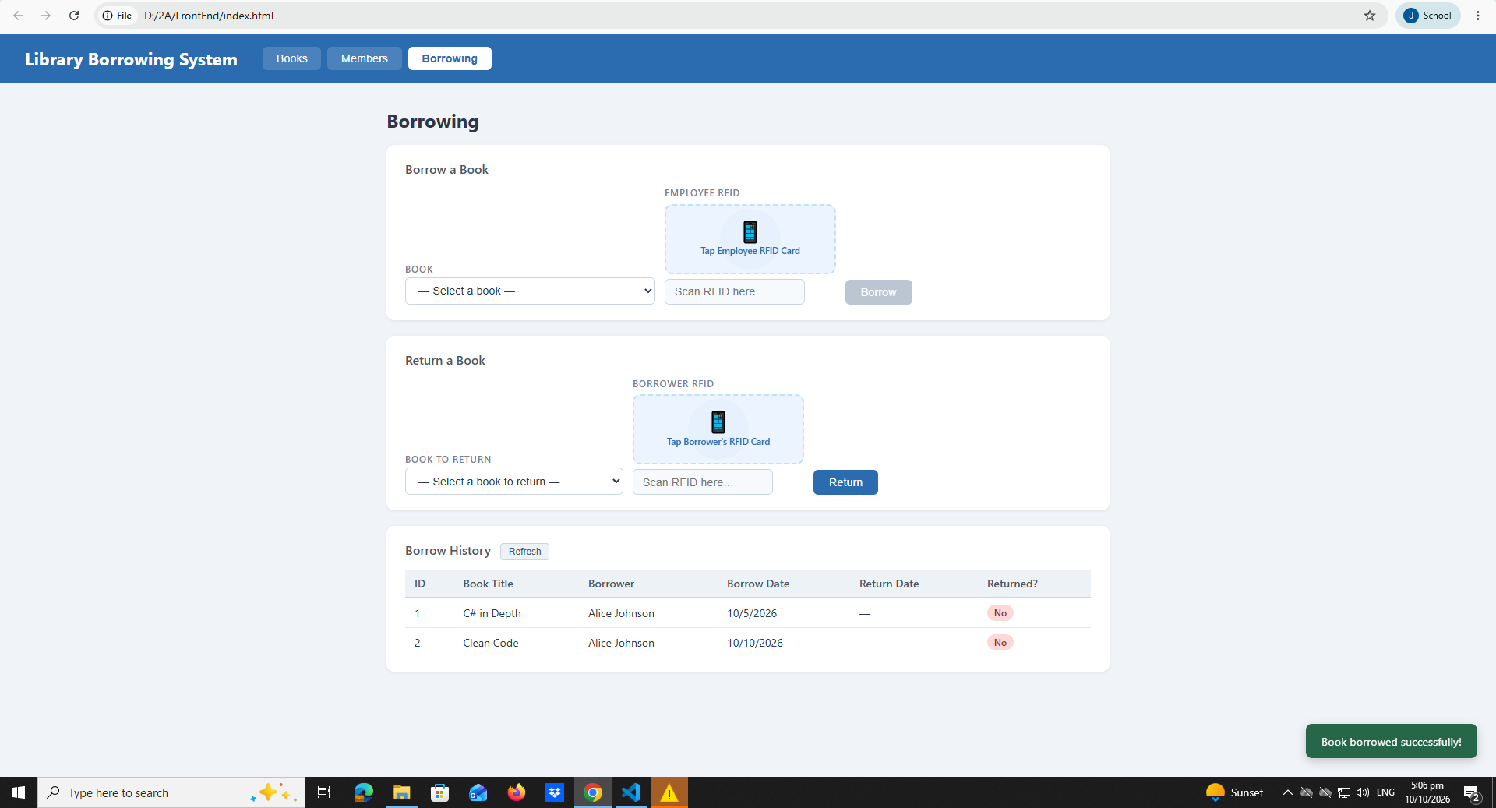

7. Test Returning
test-11-return-wrong-card
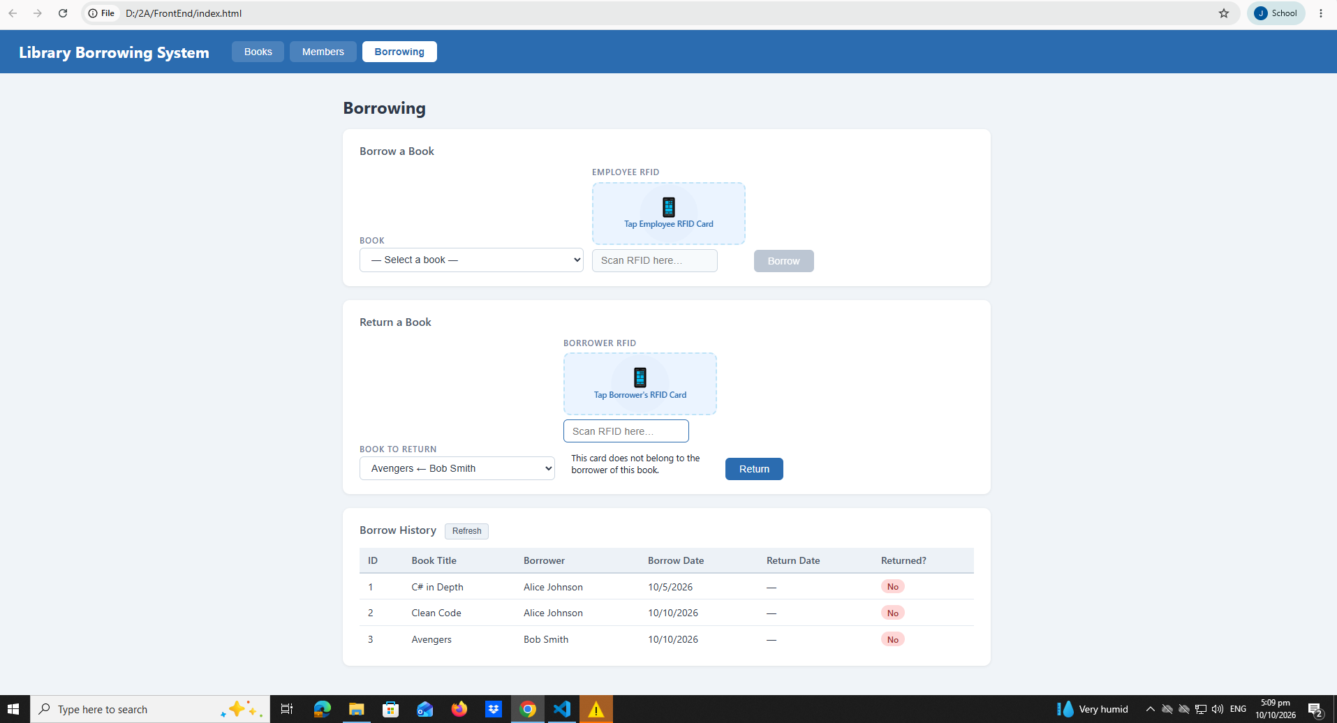

test-12-return-verified
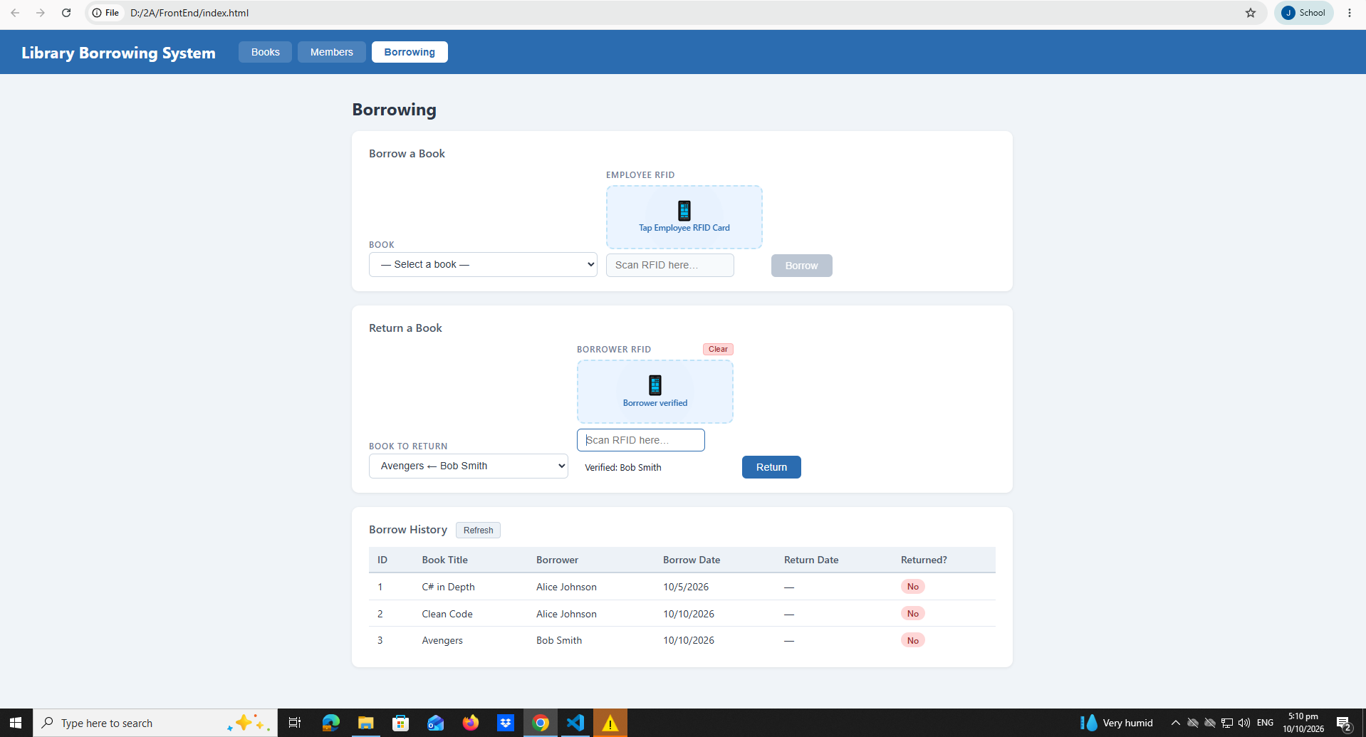

test-13-return-success
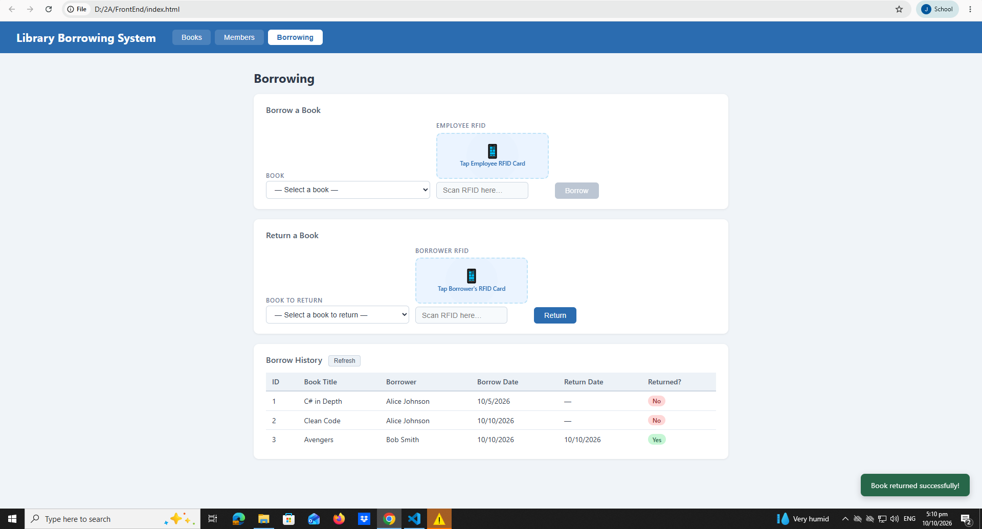

8. Final Console Check
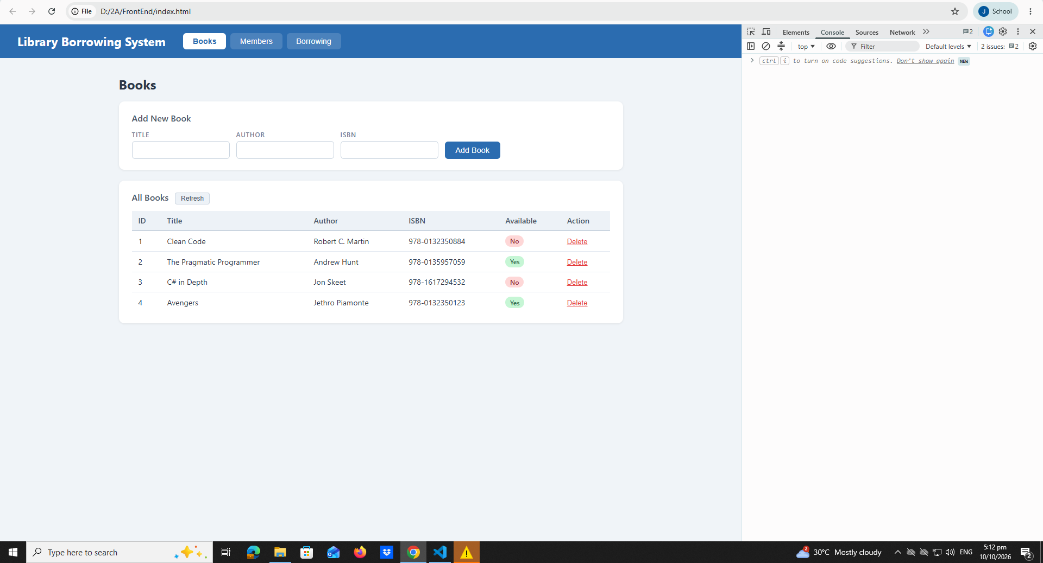

Student Reflection Questions
1.What does apiFetch() do?
Answer-to send request to the API and receive responses. It helps the application communicate with the server to get, add,update, or delete data.
2.Why do we use try/catch around API calls?
Answer-to handle errors when an API request fails. It prevents the application from crashing and allows us to display an error message.
3.What is the difference between POST and PUT?
Answer-Post is used to create new data and Put is used to update existing data
4.Why does RFID matching use rfidValue instead of studentId?
Answer-
5.Why do we refresh tables after adding, deleting, borrowing, or returning?
Answer-to display the latest data from the database so users can see the changes immediately.
6.Why does the Return dropdown use borrow record ID instead of book ID?
Answer-borrowrecordId identifies a specific borrowing transaction. A bookId only identifies the book,which may have multiple borrowing records.
7.What happens if the same event listener is added to a form twice?
Answer-the event handler may run twice when the form is submitted,potentially causing duplicate API request or duplicate records.
8.Why must the page-load code be at the bottom of the file?
Answer-placing the page load code at the bottom helps ensure that the html elements and functions have been defined before the code runs.
9.Why does an RFID reader need e.preventDefault() on the Enter key?
Answer-

